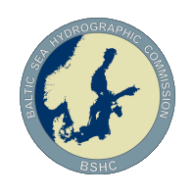
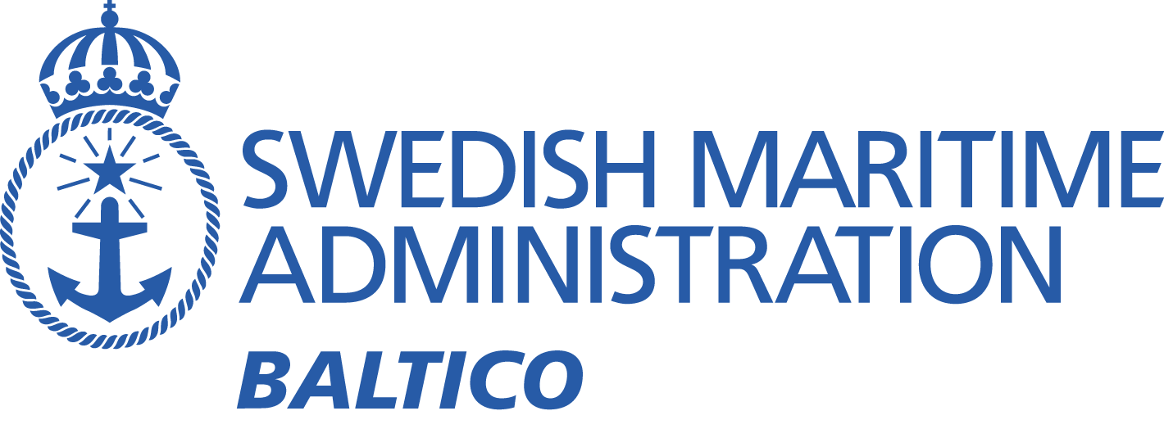

Baltic Sea MSI Working Group On-line Meeting – 26th May ‘20

Meeting minutes
Participants:
Chair Johan von Bültzingslöwen
UK Stephen Gregory (Meeting Secretary)
UK Murdo MacDonald
UK Chris Gill (IMO Navtex Co-ordinating Panel)
Norway Trond Ski (Vice Chair, WWNWS-SC & Navarea XIX Co-ordinator)
Finland Marja Aarnio
Finland Janne Virtanen
Germany Wilfried Behncke
Germany Carola Heitmann-Bacza
Denmark Ulla Bjørndal Møller
Estonia Olavi Heinlo
Estonia Darja Jokk
Estonia Jüri Grigorjev
Estonia Aleksandr Laur
Estonia Christjan Kaasik
Latvia Bruno Spels
Latvia Aigars Gailis
Lithuania Emilis Tertelis
Lithuania Mindaugas Zakarauskas
Poland Dariusz Grabiec
Poland Dariusz Tomczak
Sweden Michel Rönsen
Sweden Sandra Fyrstedt
Apologies:
Neil Salter (Chair, IMO Navtex Co-ordinating Panel)
Russian Federation

Introduction
The meeting was conducted using Skype and commenced at 07.15 UTC (09:15 CET) with an introduction from the Chair, which included information about how to find the working group website, listed under “Working groups” at the Baltic Sea Hydrographic Commission website (www.bshc.pro)
The chair also explained where at the IHO website information about BSHC meetings can be found, and a description of the modus operandi in Sweden.
He suggested that biannual meetings were possibly too far apart for the working group to function properly, and that in the future it would be preferable to have on-line meetings at 6 monthly intervals, as well as physical meetings. The first physical meeting is planned to take place in Finland in 2021.
There followed self-introductions from the other participants.

Recap of 2018 Meeting Action Points
The new action points are listed below
Agenda item 9) The Efficiency 2 Project has been closed down, so this item can be removed. The development of the S-124 standard has superseded it.
It was suggested that Eivind Mong, Chair of the S-124 Project team, should be invited to participate at the next meeting. The Chair will invite Mr Mong. (Action point 1)
The Chair referred to the S-100 section of the IHO website to find further information on the subject. (http://s100.iho.int/S100/home/s100-introduction)
There was a brief discussion on how NAVTEX appears on ECDIS with current technology. Trond Ski explained the principals; he also explained that the ‘NMEA’ specifications allowed the data to be transferred. There is a possibility of a major change in the way that mariners receive MSI, in that they will need to ‘pull’ the information rather than it being ‘pushed’, which are the methods used now.
Item 11) A request that weather warnings are included on the Baltico website.
This is completed.
Item 12) The ouput power of the Tallinn Navtex station may be too weak. Monitoring of the broadcasts at a distance of 500 km commenced in 2012 at Hoburg, Gotland. (In 2012 the Gotland site presented some security problems). However, Tallinn broadcasts have been received well at Gislovshammar, so the suspected problem needs further investigation. Chair will look into the matter. (Action point 2)
Lithuania reported interference problems at night. Navtex broadcasts from Varna on the Black Sea are interfering with Gislövshammar broadcasts. Both stations have transmitter B1 character ‘J’. There was a suggestion for Gislövshammar to change B1 character, but Christopher Gill informed the meeting that a change might not be necessary and that other, less radical solutions were preferable.
E.g: the first thing to try would be a reduction in the power at Varna. It was acknowledged that in the past a similar problem concerning Navtex broadcasts from Mondolfo in Italy was solved by changing the Tallinn B1 transmitter character from ‘U’ to ‘F’.
The IMO Navtex Co-ordinating Panel will investigate in coordination with Lithuania. (Action point 3)
A request was made for automatic monitoring of Navtex reception for the whole Baltic Sea area. Chair will look into the matter. (Action point 4)
The problem with Mondolfo has been resolved with the change of B1 character for the Tallinn transmitter. This item is completed.
Item 13) Meteorological forecast areas and navigation warnings areas in the Baltic do not coincide, and it was suggested that they should. However, it was pointed out that the present limits were agreed at the last Baltic Sea Hydrographic Commission meeting. Also, Marja Aarnio pointed out that technology already installed for the broadcast of weather warnings had fixed areas that would have to be changed. She said that she was working with Nick Ashton, Metarea I Co-ordinator, on the issue, and requested input from Navarea I Co-ordinator. Stephen Gregory asked to be included in future correspondence. This is an issue not easily solved. The chair asked if Olavi Heinlo would be in charge of this issue so it is not forgotten. (Action point 5)
The point to ask WMO to adapt the new names and borders is considered complete.
Item 16) a) Sea of Aland – Wintertime Reporting – Chart information may need changing.
b) TSS in North Quark may need to be withdrawn in winter.
Chair is unfamiliar with either issue.
Finland has no knowledge of them either, and suggests that the item be removed.
Item 24) a) Danish contact information. Nothing known by Ulla Bjørndal Møller, who suggested that the item could be considered complete.
b) Investigate how DSC is used for MSI messages. Chair asked if anyone was familiar with this issue. No one had information on the matter, so the item will be removed.

Information about current and coming major operations and changes in the Baltic Sea Region
Chair informed the meeting about the new TSS in Kattegatt that will come into force on 1st July. The new TSS will enhance safety of navigation and improve fuel efficiency by directing traffic to deeper waters. Information about this will be transmitted via NAVTEX, and also via satellite as a Navarea I warning.
No progress report on the NordStream 2 project.
There was a comment that biennial meetings are too far apart to report on some major projects, because they are often completed within that time period. This problem will be solved with more frequent on-line meetings.

New issues
Issue presented by chair:
There is an uneven workload put onto the Navtex transmitters. The Gislövshammar transmitter is the most used transmitter.
Information added to this document after the meeting: [In 2018 Gislövshammar was used to send 450 warnings, in 2019, 428 warnings was sent. Compared with Grimeton, wich sent 91 warnings in 2018 and 90 in 2019. ]
The uneven number of messages means that Swedentraffic sometimes has to select some messages not to be sent in order to keep the 10 minute time slot for broadcasts. Chair asked if it was possible to alter the Navtex service areas to make the Grimeton transmitter service area larger and cover the entire Danish east coast, the Sound, and part of the German coast. This would ease this pressure. Cristopher Gill explained that this would be possible, but there were other solutions. One was to possibly shorten individual messages. He asked for examples of the messages being broadcast. Michel Rönsen from Swedentraffic will provide statistics and examples to Cristopher Gill. (Action point 6)
Another suggestion was to more quickly replace long standing navigation warnings with Notices to Mariners.
Wilfried Behncke explained a solution that had worked in the German Bight, where the establishment of windfarms had generated too many warnings. This was for some of the warnings only to be mentioned in weekly in-force lists. Stephen Gregory asked how mariners received the detail of the warnings that were only listed. Wilfried Behncke answered that the detail was available on their website. Stephen Gregory pointed out that this was a major step, because presently there is a principle that mariners are expected to use the GMDSS to receive MSI.
Stephen Gregory explained that in the UK there is a similar problem with the Cullercoats service area, whose 10 minute time slot often fills. The solution used is to prioritise the warnings, so that only the most urgent are broadcast.
Chair, IMO Navtex Co-ordinating Panel and Navarea I Co-ordinator to work together to formulate the best solution to the problem. (Action point 7)

Other Business
The progress of implementation of the Baltic Sea Chart Datum (BSCD) was previously reported by all countries to the BALTICO meetings. This is the work of a different working group, also listed under ‘Working groups’ at the BSHC website. No further reporting to the BSMSIWG is necessary.
Christopher Gill provided an explanation of the function of the IMO Navtex Co-ordinating Panel.

Meeting conclusion
The meeting ended at 09.15 UTC (11:15 CET) with the Chair thanking all for their attendance. He suggested that the next on-line video meeting should be in October/November, and expressed the hope that a ‘real’ meeting in Helsinki would be possible in 2021.
Comments by Chair:
The Skype meeting format was not optimal for this meeting. Skype did not feel adequate for this large number of people with diverse prerequisites. Not everyone was able to see the shared screen and did not have access to video. The chair will look into other possible ways to have these on-line meetings. Suggestions are very welcome. I know that the SMA does not approve of the ‘Microsoft Teams’ or ‘Zoom’ because of the cloud based system. (Action point 8)
Have a great summer. I hope to ‘see’ you in the autumn.
/Johan

Action point list

1 | Invitation to Mr Eivind Mong to the next meeting for an update on the progress of the S-124 | Before next meeting | Chair
2 | Power of Tallinn Navtex transmitter? | Investigate | Chair/ Estonia
3 | Interference problems Gislövshammar/Varna with same B1 character. Reduction of Varna transmitting power at night? Other solutions? | Investigations and testing | IMO Navtex coordinating panel/ Lithuania
4 | Automatic monitoring system of Navtex reception? | Investigations | Chair/ SMA
5 | Areas and borders (Met/ Nav warning areas does not match) | Keeping the issue alive | Estonia/ Finland/ UK/ Chair
6 | Presentation of statistics and examples of overload for the Gislövshammar transmitter to IMO Navtex coordinating panel | As soon as possible | Swedentraffic
7 | Finding the best way to even out the workload of the Navtex transmitters | Investigations | Chair/ SMA/ IMO coordinating panel
8 | Suitable replacement for on-line meeting service. Skype not preferable. | Before next meeting | Chair/ All

