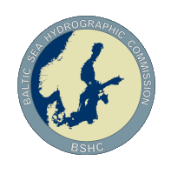
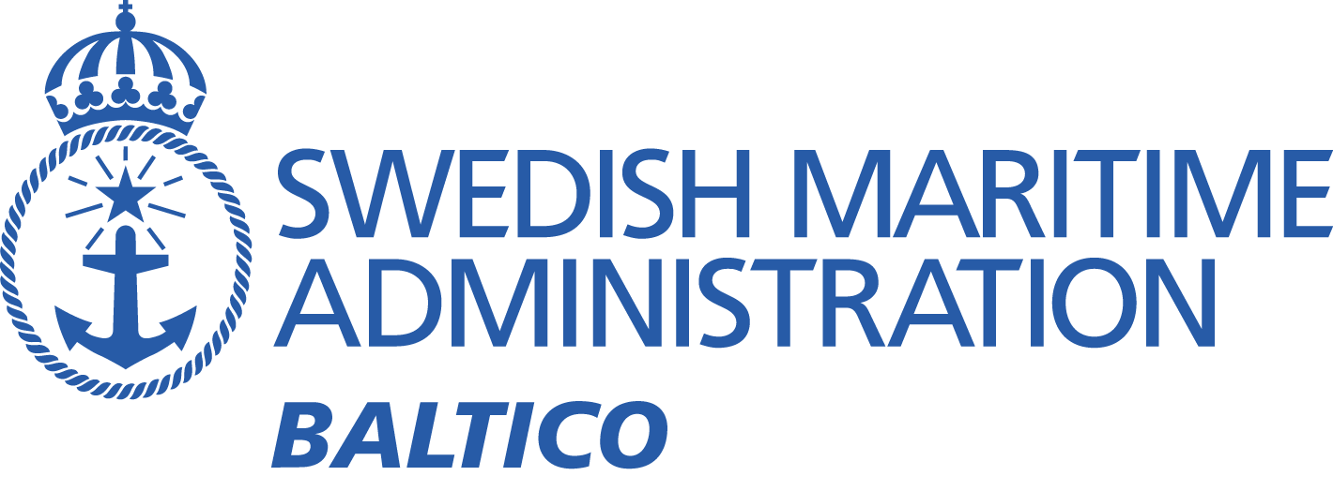

BSMSIWG3
Baltic Sea MSI Working Group On-line Meeting – 28th May ‘21

Meeting minutes
Participants:
Denmark Karsten Sondergaard
Estonia Darja Jokk
Estonia Taimi Paljak
Estonia Aleksandr Laur
Estonia Christjan Kaasik
Finland Marja Aarnio
Finland Janne Virtanen
Finland Petri Lahtonen
Finland Robert Qvarnström
Germany Wilfried Behncke
Germany Carola Heitmann-Bacza
Germany Henning Sauer
Germany Elena Maria Gnehm
Germany Thies Schlunzen
Latvia Aigars Gailis
Latvia Bruno Spels
Lithuania Mindaugas Zakarauskas
Lithuania Emilis Tertelis
Norway Trond Ski (WWNWS-SC Vice Chair & Navarea XIX Coordinator)
Sweden Johan von Bültzingslöwen (Chair)
Sweden Lisa Lind
Sweden Agneta Hedström
UK Christopher Gill (IMO Navtex Co-ordinating Panel)
UK Neil Salter (IMO Navtex Coordinating Panel)
Apologies:
Denmark Ulla Bjørndal Møller
Estonia Olavi Heinlo
Estonia Jüri Grigorjev
Poland Dariusz Grabiec
Poland Dariusz Tomczak
Sweden Sandra Fyrstedt
Russian Federation

Introduction
The meeting was conducted using Skype and commenced at 10:00 UTC. Brief introduction from the Chair, welcoming new members from Finland, demonstration of the BSMSIWG website making a run through of members.
The chair expressed need for as much assistance as possible in organising and running the working group as the work situation has been very hectic at the SMA NtM office.
Report on COVID situation- No comments or reports of any problems in keeping the MSI service from any nation.

NAVTEX

2.1 Power of Tallinn Navtex transmitter
Under investigation by Estonia
Ongoing- Chair ask Estonia to take lead. Suggestion to meet in smaller group to discuss way forward.
2.2 Interference problems Gislövshammar/Varna (Black sea) with same B1 character
Under investigation by IMO Navtex coordinating panel
Ongoing Action: NS and CG take issue forward.
Further report regarding point 2 above, submitted from IMO Navtex coordinating panel chair (Neil Salter):
“Gislövshammar, on the Baltic Sea, has the same B1 character (J) as Varna, on the Black Sea. Theoretically, as these two stations are over 900 miles apart with the bulk of mainland Europe between the two, there should not be any issues with interference. It is indisputable, however, that both Gislövshammar and Varna are experiencing occasional interference.
It has been confirmed that both stations are reducing transmission power to the minimum but this does not appear to have reduced the interference.
Consideration had been given to changing the B1 character for either of the stations. Within the NAVAREA III area (Mediterranean), there is only one unallocated B1 character, S, but this is allocated to Pinneberg, Germany, in NAVAREA I, and would probably suffer similar issues if Varna was changed to S. Similarly, within NAVAREA I, the only unallocated B1 characters are B, which is used by Bordj El Kiffan, Algeria; C, used by Odessa, Ukraine; and U, used by Mondolfo, Italy.
None of which would greatly increase the distance between transmitters and would also mean that the advantage of having neighbouring stations with adjoining B1 characters in the transmission schedule for Gislövshammar would be lost.
We are still looking for possible solutions to this issue and are open to any suggestions of a technical or administrative nature.”
2.3 Automatic monitoring system of Navtex reception?
Under investigation by Chair/SMA
Ongoing – Chair will investigate.
2.4 Areas and borders (Met/ Nav warning areas does not match)
Discussions Estonia/ Finland/ UK/ Chair
Ongoing – Marja (Fin) has had discussions with Nick Ashton (Metarea I Coordinator). No decisions made. Conflict remains.
Action. Send invitation to Nick Ashton to next meeting
2.5 Uneven workload of the Baltic Sea Navtex transmitters
Under investigation by Chair/SMA/ IMO Navtex coordinating panel
Ongoing - Previous discussion about sharing workload or making chart amendments.
Action: NS to contact Russian Navtex coordinator about possibilities to take other steps other than Navigational warnings about naval exercises.
- Navarea I satellite transmissions
3.1 Iridium SafetyCast system implementation
Report by Navarea I coordinator on implementation of Iridium system and related cost issue.
Iridium SafetyCast system is now operational in Navarea I.
Update regarding cost issue – CG gave update on Iridium implementation.
Chair discussed cost issues.
Trond Ski informed WG of ISWG set up at MSC. Trond (Nor) gave update on Iridium use on SAR within the Baltic region.
Marja shared Iridium implementation website: https://iho.int/en/iridium-safetycast-implementation-status.
Action: All MS should monitor cost issue situation as it could possibly impact the cost for all IMO member states.

S-124
Discussion on development on S-124.
Chair and Elena (Ger) participated in smaller group to provide list of NW’s choice list for the system. Plan is to have drop down lists to possibly reduce free text.

Information about current and coming major operations and changes in the Baltic Sea Region
Germany – Update on tunnel works. No new information since last meeting.
Denmark/Poland – Work on pipeline continues.
Poland – Changes to TSS were discussed.

Any other business
6.1 Norway - The operational role as national coordinator has been moved from Brevik VTS in the south and up to Vardø VTS in the north. This to gather the navigational warning operations at one place. Now both NAVAREA warnings and coastal warnings are issued from Vardø VTS.
6.2 Germany – Last working group meeting for Wilfred Behncke before retirement. Chair thanked Wilfried for his contributions to the working group.

- Next meeting
Plan for next meeting: Virtual meeting in autumn 2021 and in-person meeting in 2022.
Comment by chair: This plan was changed due to workload of chair, Covid-19 and the war in Ukraine.

Meeting concluded at 11:10

/Johan von Bültzingslöwen

