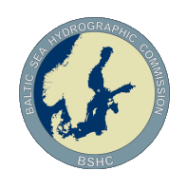
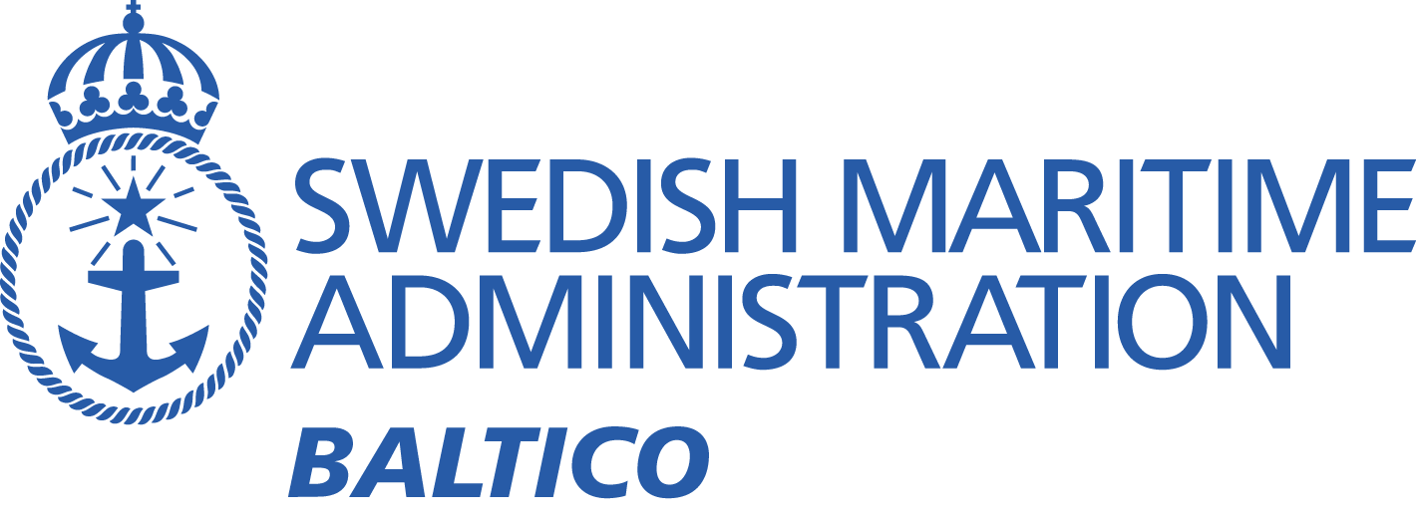

BSMSIWG4
Baltic Sea MSI Working Group On-line Meeting – September 8, 2022

Meeting minutes
Participants:
Denmark | Karsten Sondergaard
Estonia | Gabriela Kotsulim
Estonia | Aleksandr Laur
Finland | Janne Virtanen
Finland | Petri Lahtonen
Finland | Marja Aarnio
Germany | Carola Heitmann-Bacza
Germany | Henning Sauer
Germany | Elena Maria Gnehm
Germany | Petra Müller
Latvia | Aigars Gailis
Latvia | Bruno Spels
Lithuania | Mindaugas Zakarauskas
Norway | Trond Ski (WWNWS-SC Vice Chair & Navarea XIX Coordinator)
Poland | Dariusz Tomczak
Sweden | Johan von Bültzingslöwen (Chair)
Sweden | Sandra Fyrstedt
Sweden | Kristin Hallberg
Sweden | Daniel (Sweden Traffic)
Sweden | Gustav Persson
UK | Christopher Gill (Navarea I coordinator)

- Opening statement
The meeting was conducted using Zoom and commenced at 13:00 CET. Brief introduction from the Chair, welcoming everyone, especially new members.
Magnus Wallhagen, chair of the BSHC had been invited to the meeting to answer any questions regarding the current situation with the Russian Federation being temporarily suspended from the BSHC. Magnus joined the meeting shortly after approximately one hour, but no questions regarding the situation with Russia was raised.
- Adotion of the agenda
The agenda was adopted.
- Introductions
Each member introduced themselves. The website information was looked through and some corrections were pointed out. A new version of the website will soon be launched with a much easier way to update. The changes that was noted will be changed on the new website.
- Last meeting
The issues from last meeting was looked through.
  - Power of the Tallinn Navtex transmitter
The issue was closed. Alexandr Laur reported about improvements on the Navtex transmitter which improved the performance of the transmitter.
  - Interference issue (Gislövshammar/Varna)
No new information was reported regarding this issue. It was decided however to keep the issue open until the next meeting.
  - Automatic monitoring system of Navtex reception
No information regarding this issue. The working group decided to close the issue.
  - Areas and borders (Met/Nav warning areas does not match)
The areas and borders are no longer an issue. The working group decided to close this issue. It was however decided to be fruitful to invite Nick Ashton to BSMSIWG5.
Action (Chair): Invite Nick Ashton to BSMSIWG5
  - Uneven workload of Navtex transmitters
No solution has been found to resolve this issue. Issue was closed by working group but statistics will continued to be analysed and considered at future meetings to keep track of development.
Action (Chair): Continue to report and analyse statistics.
- Comments or questions regarding reports to WWNWS14 and BSHC27
The statistics in the reports were discussed. The increasing number of warnings is troubling. The 10 minute transmission timeslot for the Gislövshammar transmitter is full on many occasions. Alternative ways of providing information to shipping were discussed.
Poland raised the issue of the hard decision of having to choose to not inform about a situation that could affect the safety of shipping. The number of warnings may be hard to reduce.
The chair asked all national coordinators to make sure that the messages that are sent to Sweden traffic for Navtex transmission is as short and concise as possible.
It was suggested that the transmitted data should be analysed instead of just the number of messages, to see if shorter messages can make up for increasing number of messages.
Action (Chair): Look into possibilities to show statistics of data transfer rather than just the number of messages.
- Navarea I
The Navarea I coordinator reported on some issues regarding recent activities.
  - Information regarding NSMSIWG
The Navarea I coordinator reported about the forming of the new North Sea MSI Working Group, with the establishment of Terms of Reference at the first meeting. The Navarea I coordinator will chair the new group and will establish close cooperation with the BSMSIWG. The chair of the BSMSIWG will attend the working group meetings.
  - EGC issues
In Navarea I, the Iridium system is operational regarding navigational warnings but is still in test mode with meteorological information.
For more information regarding the implementation of Iridium SafetyCast system, please visit: https://iho.int/en/iridium-safetycast-implementation-status.
The cost issue that has been raised internationally with the introduction of Iridium system is not yet resolved. UK has no issue with the cost at this point. The issue is however closely followed by the chair and will be discussed at future working group meetings. There is a possibility that this could affect all IMO member states if some form of cost distribution is decided upon.
Action (Chair): Follow issue with cost for EGC transmissions and report any decisions made.
- Navtex
Some points regarding the Navtex system were considered.
  - Navtex interference problem (Gislövhammar/Varna)
This issue was discussed under 4.2.
  - Status of transmitters
Gustav Persson (Swe) made a presentation about the transmitters and reported about the status. The equipment is old, but is undergoing restoration.
Presentation is sent out with this document and will also be available on the BSMSIWG website when the new version is launched.

  - Automatic monitoring of Navtex reception
Issue discussed under 4.3.

- Procedures
The chair reported on a couple of issues regarding procedures.
  - Implemented routine regarding cancellations of Navtex warnings with no pre-set end date.
On September 15, 2021 a new routine was implemented to improve MSI communication between the national coordinators and to avoid having navigational warnings in-force longer than necessary. This was not in the working group report to BSHC26, but was addressed at the BSHC26 meeting in 2021.

The routine is in short that an e-mail is sent after 4 weeks to the issuing nation to inquire if a warning with no preset end date still is valid. If no reply is received the warning is cancelled after another two weeks.

The chair was given the action at BSHC26 to report to BSHC27 how many times this routine had been used.

According to data from the Sweden Traffic center, this routine has been used to cancel 7 warnings since BSHC26.
Action (Chair): Continue to follow this routine and report on the use to coming BSHC meetings.
  - Secure communications and use of E-mail.
The chair brought up this issue that was highlighted by the SMHI at a joint meeting with the SMA.
The use of E-mail is not to be considered a secure form of communication and is easily manipulated, resulting in compromised security.
Action (All): Consider alternatives to email as a form of communication and make suggestions.
- Future of navigational warnings
The S-100 decade is here and the working group have big tasks ahead of us.
  - S-124 update on development process
The chair of the S-124 project team sent a power point presentation with a update on the development. The presentation will be sent to the working group members and will be uploaded on the working group website.
Version 1.0 of the S-124 product specification is not yet finished. It will probably be sent to HSSC for approval in the spring of 2023.
  - S-124 implementation coordination in the Baltic Sea area.
The BSMSIWG was given the task as an action from BSHC26 to coordinate the implementation of S-124 in the Baltic Sea sub-area. The chair presented the task to the group. This task needs a lot of work and will take several years. The working group needs a physical meeting to make progress with this issue. Version 1.0 of the S-124 product specification needs to be approved.
Action (All): Start to consider how to best coordinate the implementation and identify where the challenges are.
- Areas and borders (Met/Nav warning areas does not match)
This working group decided to close the issue. Refer to 4.4.
- Information regarding current and upcoming operations or changes in the area
No information

Next meeting
Next meeting is planned for the spring of 2023.

Meeting concluded at 14:45 CET
/Johan von Bültzingslöwen

