
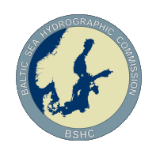
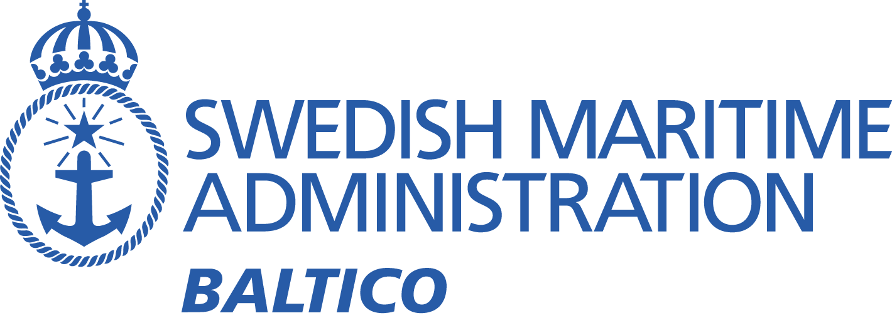

BSMSIWG5
Baltic Sea MSI Working Group On-line Meeting – June 28, 2023

Meeting minutes
Participants:
Denmark | Michael Pfeiffer
Estonia | Gabriela Kotsulim
Estonia | Siim Valgeväli
Finland | Janne Virtanen
Finland | Robert Qvarnström
Germany | Carola Heitmann-Bacza
Germany | Thies Schlünzen
Germany | Henning Sauer
Germany | Petra Müller
Latvia | Bruno Spels
Lithuania | Jurijus Gleikinas
Lithuania | Mindaugas Zakarauskas
Lithuania | Alla Bira
Lithuania | Emilis Tertelis
Norway | Trond Ski (WWNWS-SC Vice Chair & Navarea XIX Coordinator)
Poland | Piotr Pasztelan
Sweden | Johan von Bültzingslöwen (Chair)
Sweden | Daniel Stjärnström (Sweden Traffic)
Sweden | Per Löfbom
UK | Christopher Gill (Navarea I coordinator)
UK | Matthew Sheldon
UK | Nick Ashton

- Opening statement
The meeting was conducted using Zoom and commenced at 10:00 CET. Brief introduction from the Chair, welcoming everyone, pointing out the importance of cooperation especially during this time of war in Europe.

- Adotion of the agenda
The agenda was adopted.
- Introductions
Each member introduced themselves. The website information was looked through and some corrections were pointed out.

- Terms of Reference
The ToR was looked through with proposed amendments. One addition to the existing ToR has been added after the Baltic Sea strategic correspondence group meeting earlier this year. The added point is:
To coordinate and harmonize applicable S-100 based MSI services in the Baltic Sea sub-area following the IHO S-100 roadmap.
The updated ToR will be included in the working groups report to BSHC for approval.
- Last meeting
The issues from last meeting was looked through.
  - NAVTEX Interference (Gislövshammar/Varna)
No new information was reported regarding this issue. The issue will remain open until discussions have been concluded with IMO Navtex coordinating panel chair.
  - Navtex statistics
It was suggested at the last meeting that the transmitted data should be analysed instead of just the number of messages, to see if shorter messages can make up for increasing number of messages.
The chair had an action to look into possibilities to show statistics of data transfer rather than just the number of messages. Action is completed, with a negative result. The data is not available from the Navtex software.

- NAVAREA I
The Navarea I coordinator reported on some issues regarding recent activities.
  - NSMSIWG
The Navarea I coordinator (Chair of NSMSIWG) reported about an upcoming in-person meeting in November to be held in Taunton UK.
- Navtex
Some points regarding the Navtex system were considered.
  - Navtex interference problem (Gislövhammar/Varna)
This issue was discussed under 5.1
- Procedures
No information
- Future of navigational warnings
  - S-124 implementation coordination in the Baltic Sea area.
The BSMSIWG was given the task as an action from BSHC26 to coordinate the implementation of S-124 in the Baltic Sea sub-area.
The chair asked all participants about their nations development status regarding S-124.
Most MS reported about having started with S-100 development, focusing mainly on S-101 and S-102.
- METAREA I
No information
- Information regarding current and upcoming operations or changes in the area
No information
- Any other business
Poland brought up an issue with a recurring navigational warning broadcast from the Russian Federation regarding suspension of innocent passage for warships and other state-owed ships through the territorial sea of Russian Federation.
The chair referred Poland to IMO NCSR to raise questions about the legality of this navigational warning.

Next meeting
Next meeting will be in august 2024.

/Johan von Bültzingslöwen
Chair of BSMSIWG

