Questionnaire to BSHC Member States on the implementation status of Baltic Sea Chart Datum 2000 (BSCD2000), S-104 Water Level and S-111 Surface Currents

Please return to Thomas Hammarklint by email (thomas.hammarklint@sjofartsverket.se) at the latest by 15 March 2024.

Member state | country
Date of reply | yyyy-mm-dd
Point of Contact | name, institute, email

- Are all the decisions done to implement the Baltic Sea Chart Datum 2000?

1.1. When the decisions have been done or planned to be done?

1.2. What are the national decisive organizations?

- What is the national status of implementation of chart datum?

2.1. What actions have already been done?

2.2. What actions have been planned to be executed and what is the schedule?

2.3 Which ENC Approach have been updated with the new reference datum? If possible, attach a chart datum overview covering Your countries nautical charts, designed graphically or as a table, updated around January, 2023. Also, if possible, include an attribute to each named chart describing the CD difference to BSCD2000 in cm (CD minus BSCD2000). Example attached at the end of the Questionnaire (Annex).

2.4 If you implemented the attribute VERDAT in S-57 (ENC), are You using VERDAT=3 (Mean Sea Level)?

3. Has Your country established the national realization of EVRS and are the water level stations connected to this new height system (BSCD2000)?

3.1 Which organization/-s is responsible for the water level stations/data in Your country?

3.2 Which reference are used today to present water level information?
Does Your country planning to present water level information referring to BSCD2000? Doing it already today? Date decided for change the reference to BSCD2000?

3.3 Are there any plans for digital service/-s intended for the users to have the option to choose MSL or BSCD2000 as the reference level for water level information?

3.4 GNSS supported UKC control/confirmation is probably the reality in a few years. We also need reliable water level predictions for carrying out optimal loading and real time water level data to check the GNSS data. Do we need a shared service in the Baltic Sea for water level information (predictions/real-time), which fulfils nautical needs and demands?

3.5 Do we need to work together with the development of the IHO S-104 standard?

- Are the relevant national contacts and interest groups defined for the change of chart datum and water level reference?

4.1. What are the essential national interest groups in Your country?

4.2. Are the relevant point of contacts known and contacts been made to them?

  - Are You planning any information campaign about the change of chart datum and water level reference? If, yes have you published information about this somewhere?

- Have You identified any obstacles or major issues concerning transition to the harmonized vertical reference?

5.1. What are the major obstacles or issues?

5.2. What measures has been planned to avoid them?

- Connections to neighbouring countries

6.1. Which are the relevant countries to cooperate?

6.2. Are the needed points of contacts already known?

6.3. What actions have been agreed with the relevant countries (e.g. synchronising plans and schedules)?

- Are there any needs for support from BSHC?

- Do you have any other proposals or guidance to the CDWCWG to help and foster the transition process?

- Are you using GNSS and GNSS augmentation services for referring to your (bathymetric) surveys to the chart datum?

9.1 What GNSS augmentation service is used for hydrographic surveys? (If there are several augmentation services, list all of them.)

9.2 To which coordinate system, and vertical reference level/frame the GNSS augmentation service is referred to? (If there are several systems in use, list all of them.)

9.3 Does your HO require, in-house or procured, that Hydrographic survey system shall be prepared to be able to measuring the GNSS-height and refer the depth to the geoid?

9.4 Do you discuss within your HO the need of an altimetric measured Mean Sea Surface (MSS)? (For example, in order to support hydrodynamic models, shipping and / or adjust existing depth data)?

9.5 Has your HO assessed the need for dynamic geodetic reference systems (time-dependent transformation relationship) between primarily national and global reference frames?

- What is the national status of the implementation of IHO S-104 Water Level and S-111 Surface Currents?

10.1 What actions have already been done?

10.2 What actions have been planned to be executed and what is the schedule?

10.3 Are all the decisions done to implement S-104 and S-111?

10.4 When the decisions have been done or planned to be done?

10.5 Which organization/-s is responsible for observed and modelled/ forecasted water level (Refer to 3.1) and currents in Your country?

10.6 How is Your country represented in the IHO Tides, Water Level and Currents Working Group (TWCWG)?

Annex

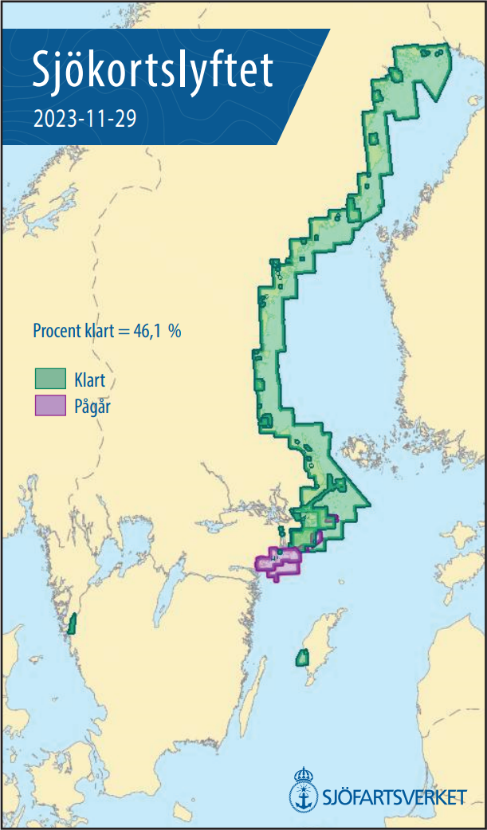

Example of ENC Approach from Sweden (updated 2023-11-29): Green cells are referring to the new chart datum BSCD2000, purple cells are ongoing adjustments to BSCD2000 and the rest of the cells refer to various Mean Sea Level.

